Teamsite integration

Description of the process

The Content Exchange Engine provides integration with Interwoven’s Teamsite by adding a Translate Files directive to the Teamsite GUI. Teamsite users may select one or more files or directories from a Teamsite window, choose the Translate Files menu item and the names of the selected file(s) will be sent to a servlet within the Content Exchange Engine for processing (fig. 1).

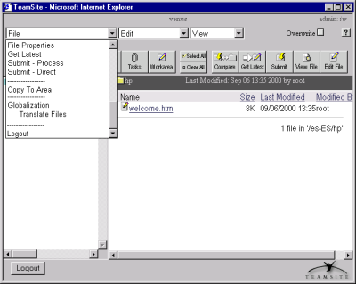
Fig. 1

The servlet will validate the user access privileges, and verify that the selected files are not already part of an on-going translation Job. The servlet will return a new page (fig. 2) where the user will be asked to choose a Job Description and to pick a Job Template and a Data Source Profile to be associated to the selected files (fig. 2).

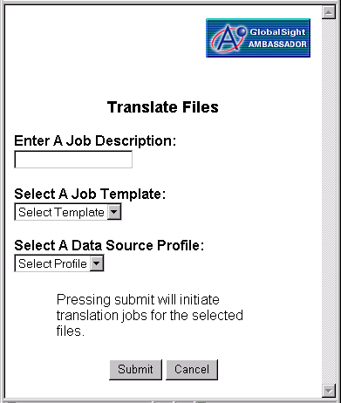
Fig. 2

After the user submits his/her choices, the servlet will verify that all selected files are readable, and will also translate their paths from the Teamsite file system the Ambassador file path structure, and will create a unique batch ID for all files. The servlet will then publish a TSSelectedFileEvent for each individual file to the Teamsite Source Adapter (the Teamsite Source Adapter executes within Active Broker’s Java VM).

A Digression on File Paths

The original file paths submitted by the user from the Teamsite GUI correspond to files stored within the file system of the server dedicated to the Teamsite application. Since the Content Exchange Engine runs in a separate server, the implementation of the software assumes that as part of the installation, a symbolic link will be established from the root of the Content Exchange Engine file system to the root of the Teamsite file system. Therefore any original Teamsite absolute file path can be treated by the servlet as an absolute file path within the Content Exchange Engine file system and all Teamsite files can be checked for readability directly (see above) by the software.

The translation of file paths mentioned above is necessary to convert the original Teamsite file path of each submitted file into a corresponding file path within the Ambassador file system. This new file path will be used by Ambassador as temporary storage while it works on the file.

For example, if the following Teamsite filepath is submitted to the Content Exchange Engine:

“/iw4/iwmnt/default/main/DemoBranch/WORKAREA/Adobe/es-ES/hp/welcome.htm”

it will be converted into the following file path:

“/export/home/diplomat/as-SSL/docs/TSSLink/main/DemoBranch/WORKAREA/Adobe/es-ES/hp/welcome.htm”

The functional description continues

After all the files have been successfully published, the servlet will acknowledge the completion of the operation to the user by returning the following message (Fig. 3).

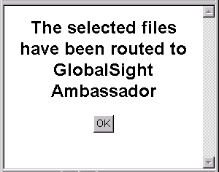
Fig. 3

The TSSelectedFileEvents are received and processed by the TeamsiteSourceAdapter.

The process described above is illustrated in figure 4 below.

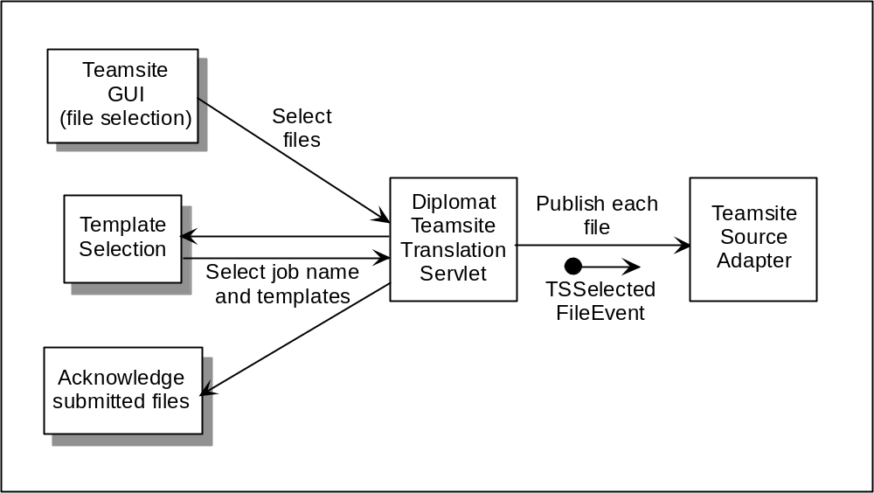
Fig. 4

For each TSSelectedFileEvent received by the TeamsiteSourceAdapter the adapter invokes a TSImportFileOperation which reads the contents of the file whose name was included in the event. The import file operation then creates a new event depending on the type of the file’s content (e.g. XML, HTML). The new event encapsulates the file’s data and a string of Event Flow XML. Event Flow XML specifies all the parameters that pertain to the file (e.g. Localization Profile, Data Source Profile, batch ID, job name, etc.) as well as the process that the file will undergo. The further processing of the file depends on the data type of the file content which is specified in the Data SourceProfile.

The event is then published to Active Broker who then forwards it to the Extractor. The Extractor determines the data type based on the data source profile embedded within the Event Flow XML and proceeds to parse the data. The Extractor then forwards the Job to GSA for processing (see fig. 5). Once the job is process by GSA, the translated files are sent to the Merger via a Source Adapter. The merger publishes each file individually to the TeamsiteTargetAdapter with a TeamsiteMergedEvent.

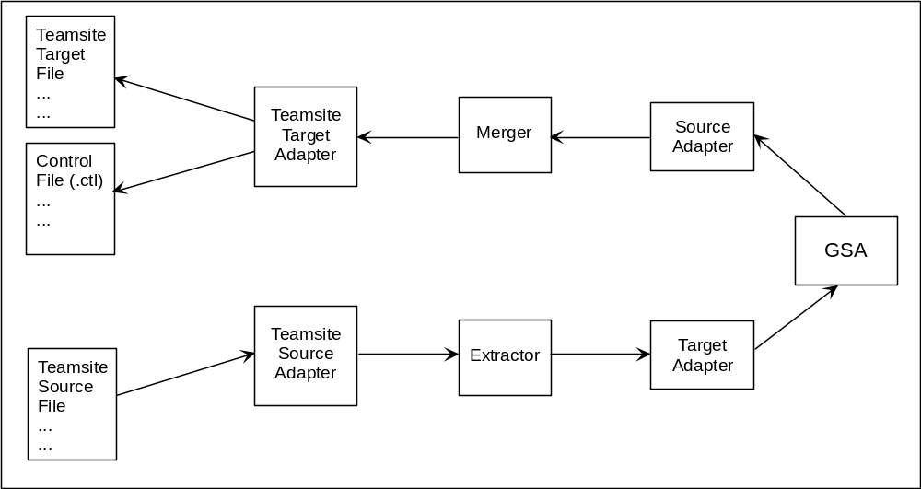 Fig. 5

The Teamsite Target Adapter receives a TeamsiteMergedEvent which contains a byte array with the contents of the translated file and a string of Event Flow XML that identifies the file and its contents. The Teamsite Target Adapter creates two files in the Teamsite Export Directory (a designated directory within the Teamsite file system). Both files share a uniquely generated name but they distinguish from one another by attaching a “.ctl” extension to one of the two file names. The file without the extension will contain the translated file contents. The file with the .ctl extension is considered a control file and will contain directives that include the actual file name of the translated file (“FILENAME” parameter -- same as that of the original source file), the relative file path after the WORKAREA directory (“RELPATH” parameter), and the path of the WORKAREA directory (“DIR” parameter) and a count of the number of attempts to copy the file to its final directory.

The files are written to the Teamsite Export directory because only the super user of the Teamsite server has access to the portion of the file system where the Teamsite file system is located. To circumvent this problem, the installation of Content Exchange Engine includes a provision for setting up a CRON process in the Teamsite server that will periodically check for new files in the Teamsite Export Directory. This process executes with root privileges and is capable of copying and renaming a file into the desired location in the Teamsite file system.

